Name ______________________­­­­­­­­­­­­­­­­____________________________________________ Date: ___________ Per: ___________

**Intro to Energy Lab Analysis**

1. Based on your observations for part 1 and part 2, what can you conclude about the total energy in a system?
2. How is your answer to #6 possible if gravitational potential energy and kinetic energy do not stay the same the whole time?
3. Observe the following situations. Draw the possible bar graphs for the situation shown. You can verify your results with the simulation, if needed.

|  |  |  |  |
| --- | --- | --- | --- |
| Top of the ramp, stopped for just an instance. |  | Bottom of the ramp, zooming past the middle. |  |
| Mid-way down the ramp, moving about mid-speed. |  | 3/4 of the way down the ramp, moving pretty fast. |  |

1. Draw where the skater might be based on the bar graphs shown. You may verify your responses with the simulation, if needed.

|  |  |  |  |
| --- | --- | --- | --- |
|  |  |  |  |
|  |  |  |  |

**Track Playground Ranking Tasks (friction turned off)**

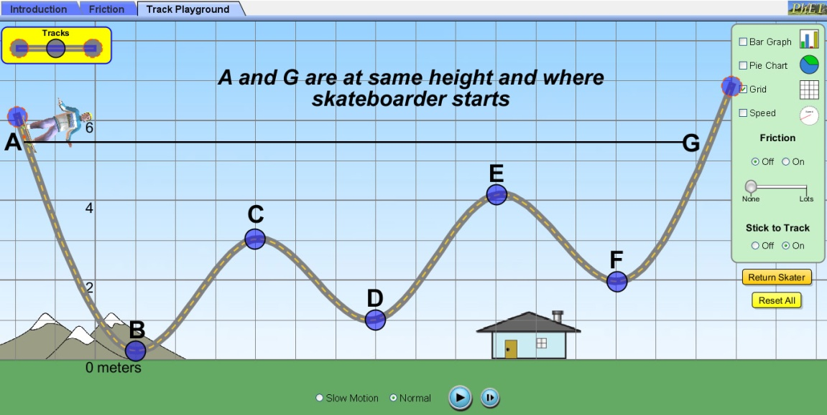

1. Rank the skateboarder positions A – G above in order of greatest potential energy to least potential energy. Ties are possible.

___ ___ ___ ___ ___ ___ ___

1. Rank the skateboarder positions A – G above in order of greatest kinetic energy to least kinetic energy. Ties are possible.

___ ___ ___ ___ ___ ___ ___

**Conclusion Questions: (*circle the correct answers-assume there is no friction*)**

1. At the highest point, kinetic energy is *zero / maximum* while the potential energy is *zero / maximum*.
2. At the lowest point, kinetic energy is *zero / maximum* while potential energy is *zero / maximum*.
3. Mass *affects / does not affect* the amount of energy.
4. As an object falls in gravity, kinetic energy *increases / decreases / remains the same*.
5. As an object falls in gravity, potential energy *increases / decreases / remains the same*.
6. As an object falls in gravity, total mechanical energy *increases / decreases / remains the same*.
7. An object that is slowing down has a kinetic energy that *increases / decreases / remains same.*
8. An object that is speeding up while not changing height has a potential energy that *increases / decreases / remains same*.
9. As an object speeds up while not changing height, the total mechanical energy *increases / decreases / remains the same.*
10. As an object slows down while not changing height, the total mechanical energy *increases / decreases / remains the same.*